Igus Lead Screw Options
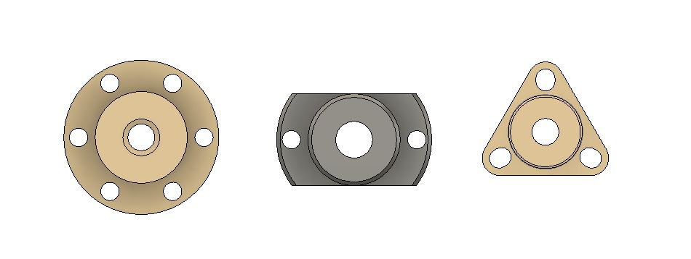
The Workhorse Printer uses Igus dryspin high helix lead screw.
Workhorse Printer
Igus

dryspin high helix lead screw: stainless steel, rolled
DSTL-LS-10x50-R-ES 10x50

Igus Lead Screw Nuts | $ 35.78 | DST-JFRM-2525DS10X50 | Ds10x50

Higher efficiency due to optimized thread angle
Due to a flatter thread angle of about 30° in Dryspin high helix lead screws (similar to a trapezoidal thread), the applied force is efficiently converted into a translational motion. Compared with a steeper thread angle, this means a lower power loss.

Increased life performance with pitch asymmetry due to the larger distances between the individual thread turns, the high performance polymers tribologically optimized polymer in the thread turns can be extended by a factor of 1.3and wear resistant material and higher levels of efficiency are crucial for up to 5 times longer. Backlash can be minimized with zero-backlash threaded nuts and spring pretension.
Igus Part Numbers

Lead Screw Nut Material: Dry-tech Polymers
Igus high performance polymers are used in DryLin linear drive units-lead screw drives Self-lubrication bearing material for dry-running conditions are maintenance-free.
Optimized Materials: DryLin lead screw nuts optimize friction properties of lead screw with the lowest possible wear rates and friction.
WorkHorse Printer With Anti-Backlash Nuts
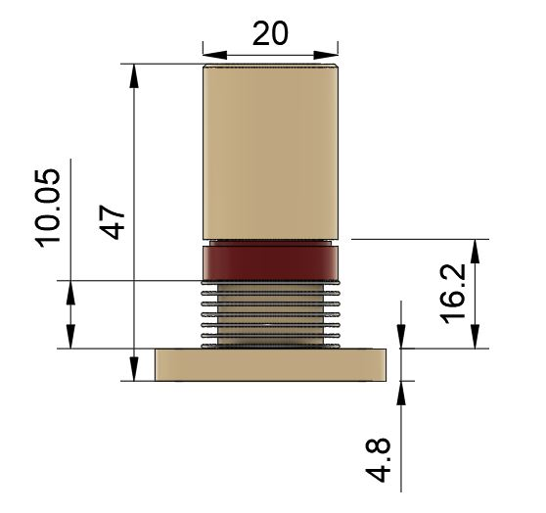

Part # JFRM-ZB-0001-HH10X50
Igus Drylin High Helix Thread Nut With Flange- Zero Backlash - JFRM
- Material: iglide J
- Thread direction: Right-hand thread
- Thread type: High helix threads
- Design: Standard
- Cylindrical lead screw nut with flange
- Zero-backlash
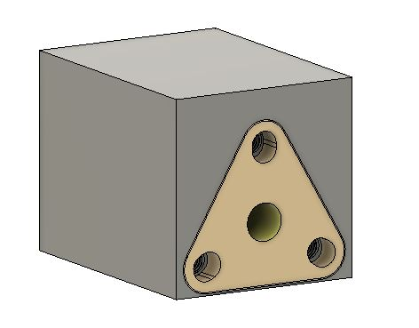

Required Drive Torque
The required drive torque of the nut is obtained from
- axial load
- lead screw pitch
- coefficient of surface friction

Workhorse C-Carriage Using Lead Screw Nut With Flat

dryspin flange lead screw nut with flat, high helix thread, JFRM
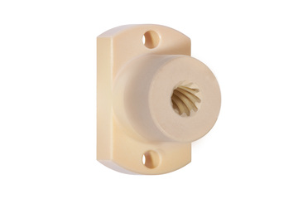
See Igus Product

- Material: iglide J
- Thread direction: Right-hand thread
- Thread type: High helix thread dryspin
- Cylindrical lead screw nut with flange
- Flange flat - For mounting

Part no. DST-JFRM-252525DS10X50
Thread
Ds10x50 39.21 USD

C-Carriage C-Carriage CAD Model Download
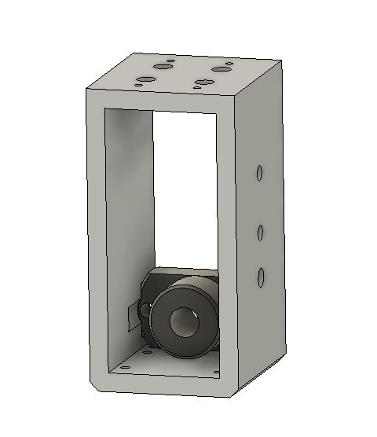
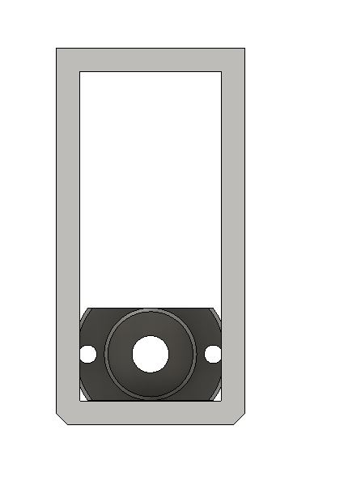

Related Content
WorkHorse BOM
Igus Lead Screw
Linear Rails
WorkHorse Frame
WorkHorse Motors
WorkHorse Printer: Users Guide
Duet Wifi Setup
Duet 2 vs Duet 3
WorkHorse 3D Printer
Recommended Print Settings
3D Distributed

Z-Axis Lead Screw Updates

Part List
Igus 761mm Long (X Axis)
$ 93.23
DST-LS-10x50-R
DST-LS-10X50-R-ES
Igus 485mm Long (Y Axis)
$ 74.80
DST-LS-10x50-R
DST-LS-10X50-R-ES
Igus Lead Screw Nuts
$ 35.78
DST-JFRM-2525DS10X50
Ds10x50
12mm T12x2 Trapezoidal ACME Lead Screw w/ Brass Nut

